|  |  |  |  |
| --- | --- | --- | --- |
|  | Severity Level | Details | status |
| 1 | Moderate | Cannot delete a group in the library item screen. Gives object reference not set to an object. |
| 2 | Next release | A user has no visibility into who owns a library. If you want to suggest to someone who to add/delete there’s no way to do this. |
| 3 | Moderate | Could not delete a library – got an error message. I THINK this took afterwards (but now writing this the next day) |
| 4. | Moderate | I deleted a group called Chaos Department. It took. Then I went in and added a group called Chaos Department. A message told me that that group name was already taken. |
| 5 | Next release | On the archive screen we could consider switching out the status bar with the file directory bar so people can see the whole file name being processed. |
| 6 | Consideration? | See the invalid retention code column error from the log. Occurred when I was doing a regular archive |
| 7 |  |  |
| 8 |  |  |
| 9 |  |  |

#1

#1System.NullReferenceException: Object reference not set to an instance of an object.

at ECMLibrary.frmLibraryMgt.RemoveGroup()

at ECMLibrary.frmLibraryMgt.btnRemoveGroup_Click(Object sender, EventArgs e)

at System.Windows.Forms.Control.OnClick(EventArgs e)

at System.Windows.Forms.Button.OnClick(EventArgs e)

at System.Windows.Forms.Button.OnMouseUp(MouseEventArgs mevent)

at System.Windows.Forms.Control.WmMouseUp(Message& m, MouseButtons button, Int32 clicks)

at System.Windows.Forms.Control.WndProc(Message& m)

at System.Windows.Forms.ButtonBase.WndProc(Message& m)

at System.Windows.Forms.Button.WndProc(Message& m)

at System.Windows.Forms.Control.ControlNativeWindow.OnMessage(Message& m)

at System.Windows.Forms.Control.ControlNativeWindow.WndProc(Message& m)

at System.Windows.Forms.NativeWindow.Callback(IntPtr hWnd, Int32 msg, IntPtr wparam, IntPtr lparam)

#3

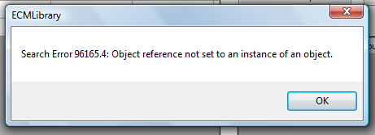

08/04/09 7:01:53 AM: Debug set OFF for: clsSql

08/04/09 7:02:41 AM: clsDataGrid : PopulateGrid : 158 : Object reference not set to an instance of an object.

#4

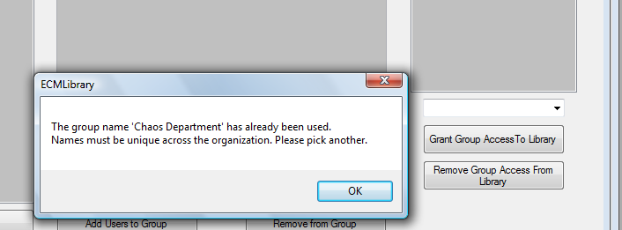

#5

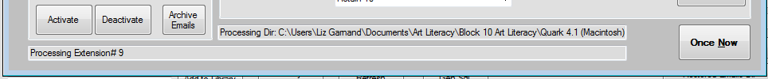

08/04/09 8:29:18 AM: clsDatabase : ExecuteSqlNewConn : 9442a: Invalid column name 'RetentionCode'.

08/04/09 8:29:18 AM: clsDatabase : ExecuteSqlNewConn : 9442b :

Update DataSource set RetentionCode = 'Retain 10' where SourceGuid = '3886d901-3daf-4904-9af9-29261746d11f'